BSc Computing Global Online Program
HLUM HTET AUNG
Web Technologies

Report Contents
Sapphire Fun Website Report 3
I. Description 3
II. Background Research 3
Similar Website Reference 3
Technical Research 4
Sapphire Fun Design Implementation from References 5
III. Sapphire Fun Games and Features 5
Mini-Games Section 6
Interactive Choice Based Story Games 6
Game Review and Fun Fact Section 7
User Interface & Design Features 7
IV. Site Map and Organization 8
V. Wireframe of Sapphire Pages 9
Index 9
About Us 10
Mini Game Page 10
Story Game Page 11
Fun Fact Page 11
VI. Project Plan 12
Timetable 12
Click Up List 13
Gantt Chart 14
TO DO List Table 15
References 16

Sapphire Fun Website Report

Description
Sapphire Fun is a website with interactive brainstorming games and a bit more in-depth short story game. The website is intended for all ages to pass time. Visitors can explore classic mini-games such as Tic Tac Toe, Wordle-style puzzles, Minesweeper, Sudoku, alongside interactive narrative experiences of short-meaningful story games that highlight how small choices can shape different outcomes and how all choices matter in life. In addition to game features the website has additional plans to include game reviews, fun facts, and creative content designed to keep players entertained.

Background Research

Similar Website Reference
The background research and referencing for Sapphire Fun based on Crazy Games where users can play multiple arcade style games and some multiplayer games such as snake.io. The crazy games is a fun interactive website for people of all ages and attract users with their wide variety of web-based games. They navigate the site with sidebar to make game screen as large as possible. The sidebar also provides cleaner pop up for navigation compared to most header drop down settings in most websites.
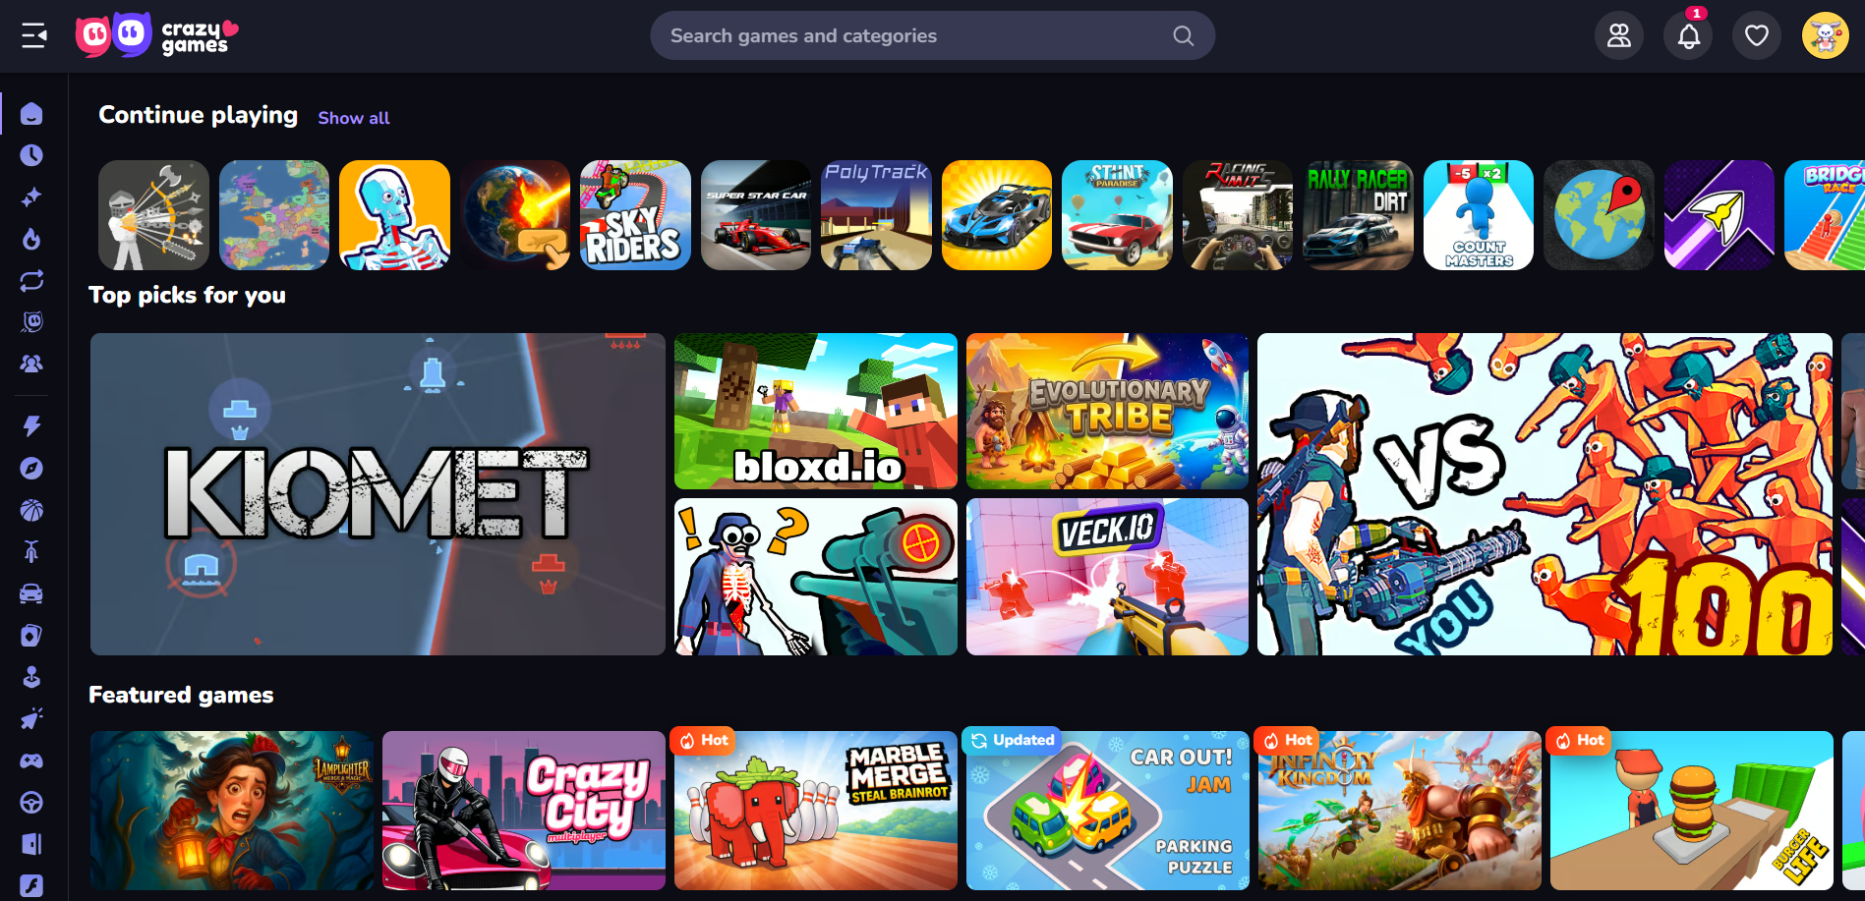
Figure II-1 Crazy Games Index Layout
Other game websites, such as Poki, Addicting Games, and Play hop were also researched. However, crazy games’ interface is cleaner and more polished compared to other websites. Based on an attractive UI, functionality, and features, crazy games website was chosen as a reference.
Design Reference - (CrazyGames, n.d.)

Technical Research
For this website design and games implementation, HTML, CSS, and JavaScript libraries and frameworks, as well as APIs were researched. This is to improve the design and attractiveness of the website design and interface.
Regarding HTML, research was done in moderate since there are no styling and designs involved. HTML foundation for games such as sudoku and Wack-a-mole will be studied and prepared by using YouTube tutorials as a reference.
For CSS, frameworks for front-end UI such as Tailwind CSS, Bulma, and Bootstrap were considered but decided to be used in bare minimum or none at all. Frameworks can provide Sapphire Fun with outstanding UI design but require minimum work to implement them. Thus, the website implementation will not apply framework as long as possible except for some minor buttons or icons when needed to avoid image copyright from browsers.
JavaScript for word and brainstorming games can benefit by implementing frameworks from Alpine and React. However, these framework implementations are still in deciding factor for them to be included or not. Using these frameworks can significantly boost the performance of the games while reducing workload. However, reliability on these frameworks can also increase and overshadow the manually written codes.
Regarding API, consideration in wordle API and other game APIs were made. Games from some websites offer API keys and codes to implement their games. This can ensure Sapphire Fun can add several interactive games for users to have fun. However, these games and APIs can reduce the individual workload, and it is considered to be used only if the expectation for the website can’t be met at the very end for quick implementation process.

Sapphire Fun Design Implementation from References
For the website Sapphire Fun, the researched features are to be implemented on the website. For example, the use of sidebar is better for more clearance and neat design with retractable sidebar instead of using navigation bar inside header. With retractable sidebar, it also provides larger play screen for the users for better comfortability and experience.
Additionally, researching technical fields like frameworks, APIs, and design layouts from other web-based game sites provide support and help with coding and implementation stages. These frameworks can be used as a last resort in case something went wrong in the implementation and requires fast and easy design layouts and implementations. However, these frameworks and APIs are researched and noted for only small implementations if the time constraints become a problem. All designs in Sapphire Fun will be developed and implemented using manual coding as much as possible. Additional information on framework and API usages will be mentioned in the second report with the completed functional web designs and game pages.

Sapphire Fun Games and Features
Sapphire Fun includes many games and features for the users to enjoy spending time. The features can attract users to keep coming back, while games entertain the players. Regarding features, Sapphire Fun will include multiple features to keep the users entertained. Proposed features that are ensured to include in former implementation stage are as follows.

Mini-Games Section
Mini-Games are the core features that are planned to be implemented in the Sapphire Fun. In this report, each mini game included in the implementation stage will be mentioned with the reason why they were chosen.
- Tic Tac Toe – This game is the most common well-known foundation of mini games.
- Wordle Style Game – Wordle is one of the most played word games from New York Time and it is a must for a website featuring mini games.
- Whack-a-Mole – Whack a mole is a non-typical game in many websites, although it is a classic game among many other mini games.
- Reaction time test – This is a trendy fun exercise where you can test your reaction time as the color changes and stopwatch starts.
- Sudoku – This is the classic number game where many people like to play for brainstorming.

Interactive Choice Based Story Games
Sapphire will include mini story games where it is short but incredibly fun choice-based stickman games. The game genre will be based around visual novel category where the story happens, and each story can take up to 5-10 minutes of play time. Game topics planned to be implemented in the story genre are –
- The Reply – The story is based around how small decisions can impact one’s life.
- An Apology – The story based around the mistakes in the past and how your decisions will shape your future.
These two are the planned stories for Sapphire Fun website if the time constraint allows. The titles of the stories and the plot will be original work while some arts may involve artificial intelligence generated photos, such as rooms, stickman poses, and game environments due to the time constraints. Story games can be very attractive for many users.

Game Review and Fun Fact Section
This feature is for the users to see the game reviews from other players before diving into the game and fun fact section is referenced from the Neal website (Neal, n.d.) where astronomy and deep-sea fun fact is widely known. This feature is a great way to improve user attraction.

User Interface & Design Features
The user interface and design features include navigation sidebar that is linked to other pages. It also includes responsive layout to work on both desktop full screen and small or cropped screens. This ensures that the website is responsive on both desktop and mobile. The website will feature sapphire themes with colors and effects. All of these features are included in order to attract users with a great UI/UX design.

Site Map and Organization
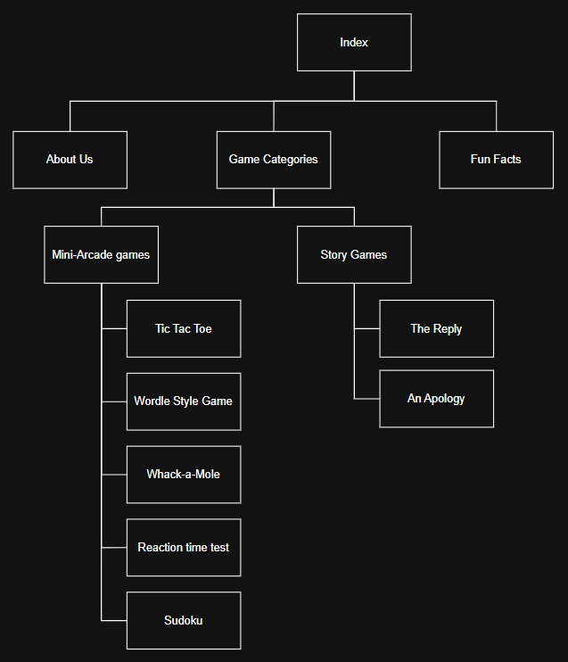
Figure IV-1 Sapphire Site Map (Draw io)
The sitemap presents the navigation of the users of the webpage Sapphire through a definite hierarchical pattern. The visitors start at the Index that serves as the homepage and the general starting point of navigation. On that page, four major pages are available to them: Game Categories, Game Reviews, Fun Facts and About Us. In the Game Categories page, two additional sections are offered, including Mini-Arcade Games and Story Games. Mini-Arcade Games is connected to single game pages like Tic Tac Toe, Wordle Style Game, Whack-a-Mole, Reaction Time Test and Sudoku. Story Games is connected with The Reply and An Apology. In general, Sapphire has a systematic top-down navigation model which directs users on general pages to more specific content in a systematic and rational manner.

Wireframe of Sapphire Pages
Below is the wireframe designs made in Figma for Sapphire pages and body components layout. Regarding features there is side bar icon with three lines at header with the logo and name. In designs, games mentioned in the feature section, such as tic tac toe, wordle, and whack a mole, can be seen. Additionally, the story games are also present with the categories separated by mini games and story games.

Index
The main page of Sapphire Fun and it is inspired by the layout of crazy games.
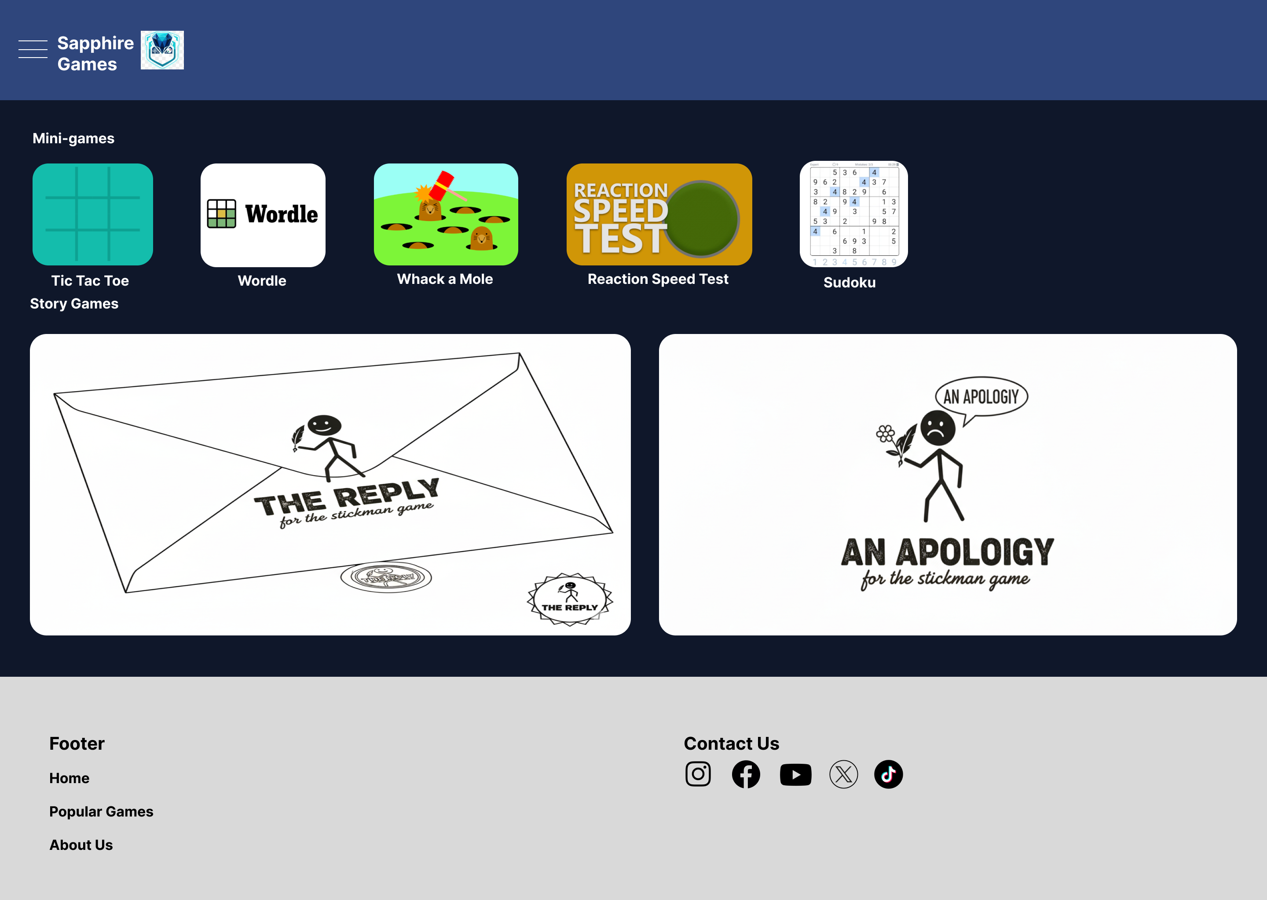
Figure V-1 Index Page

About Us
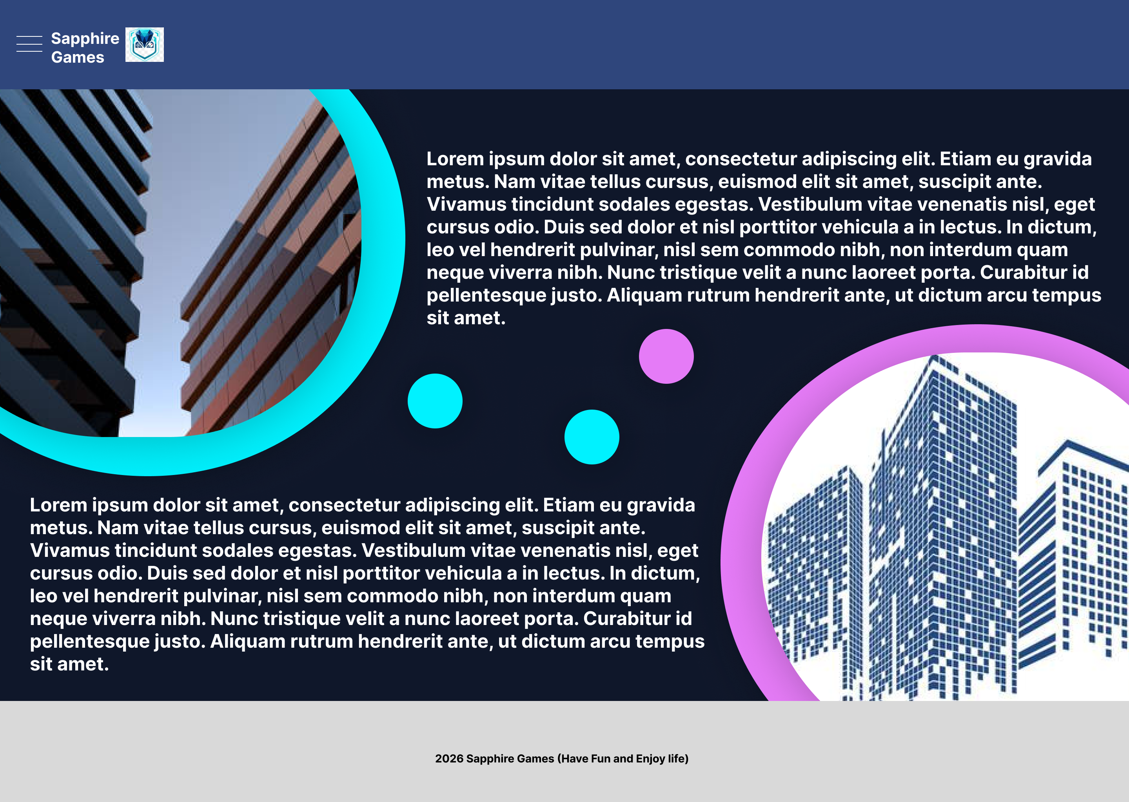
Figure V-2 About Us Page

Mini Game Page
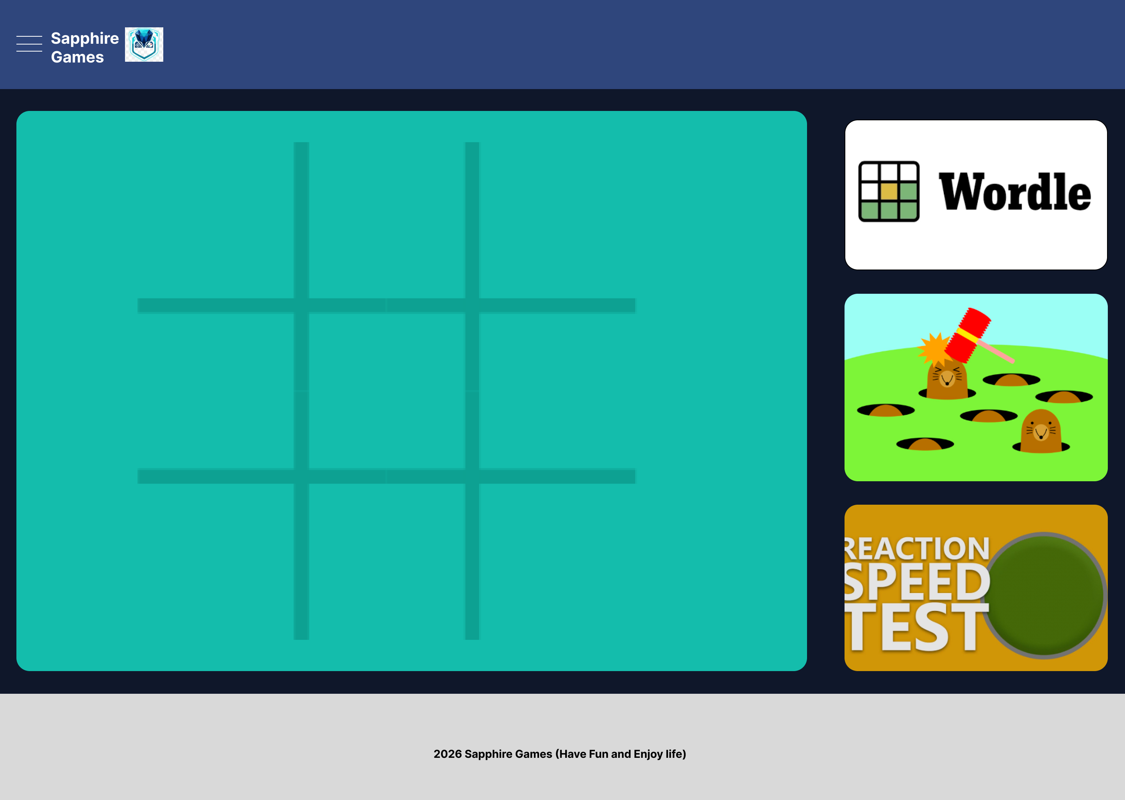
Figure V-3 Mini Games Page

Story Game Page
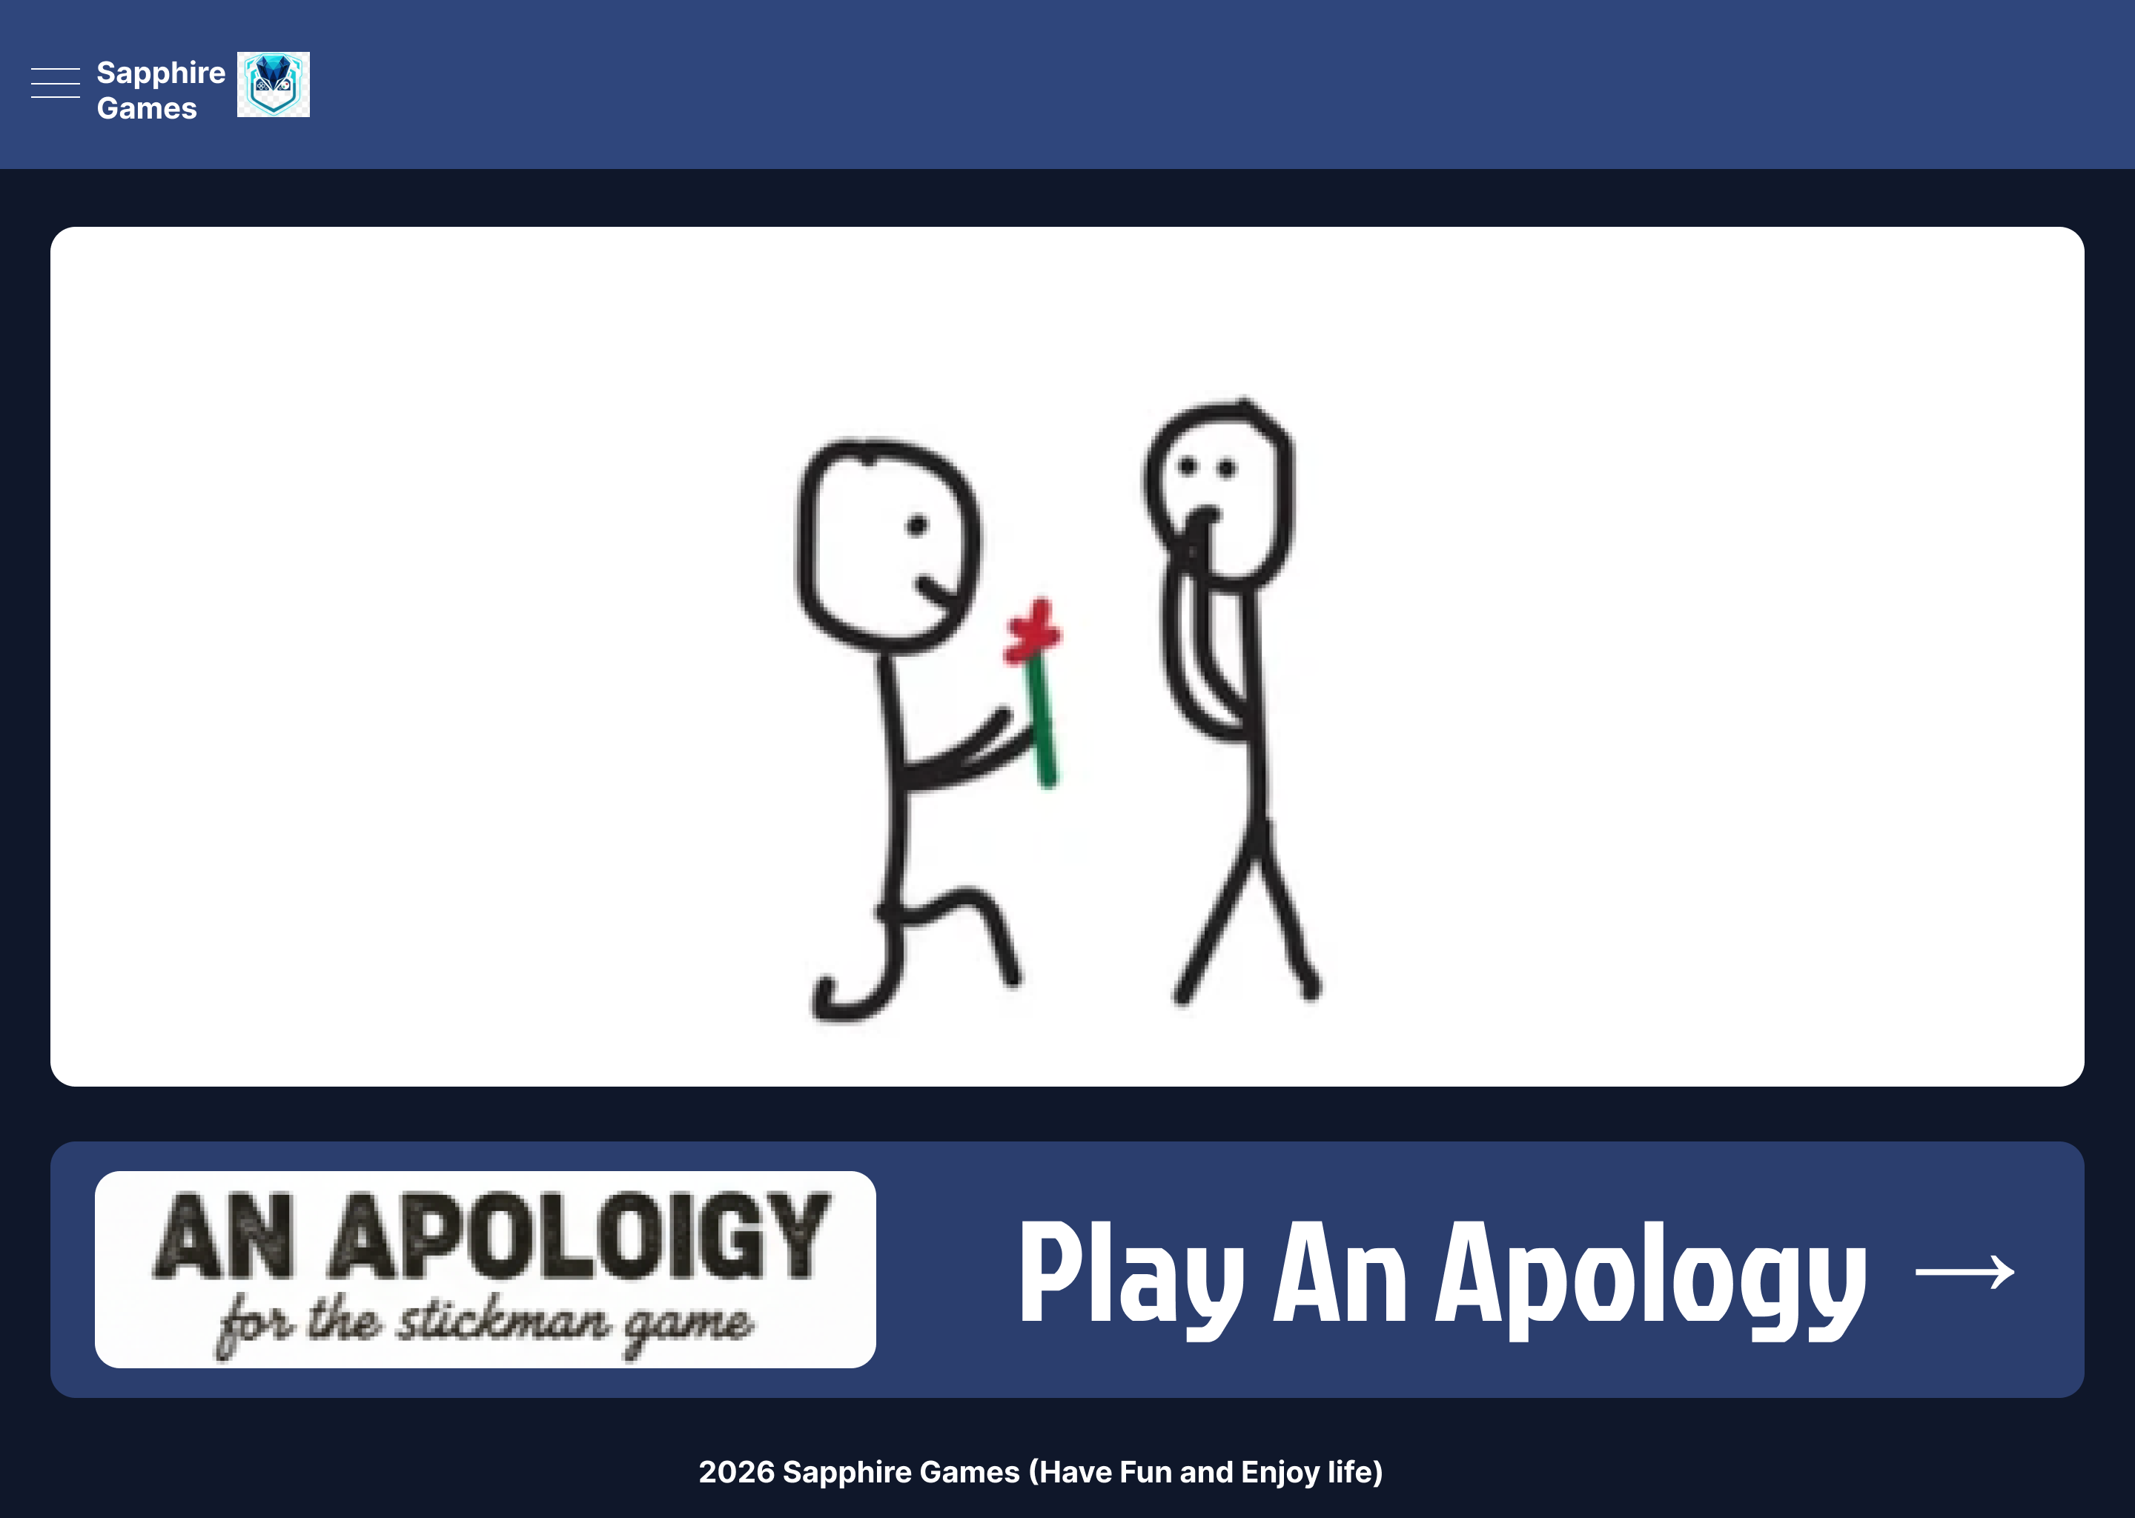
Figure V-4 Story Game Page

Fun Fact Page
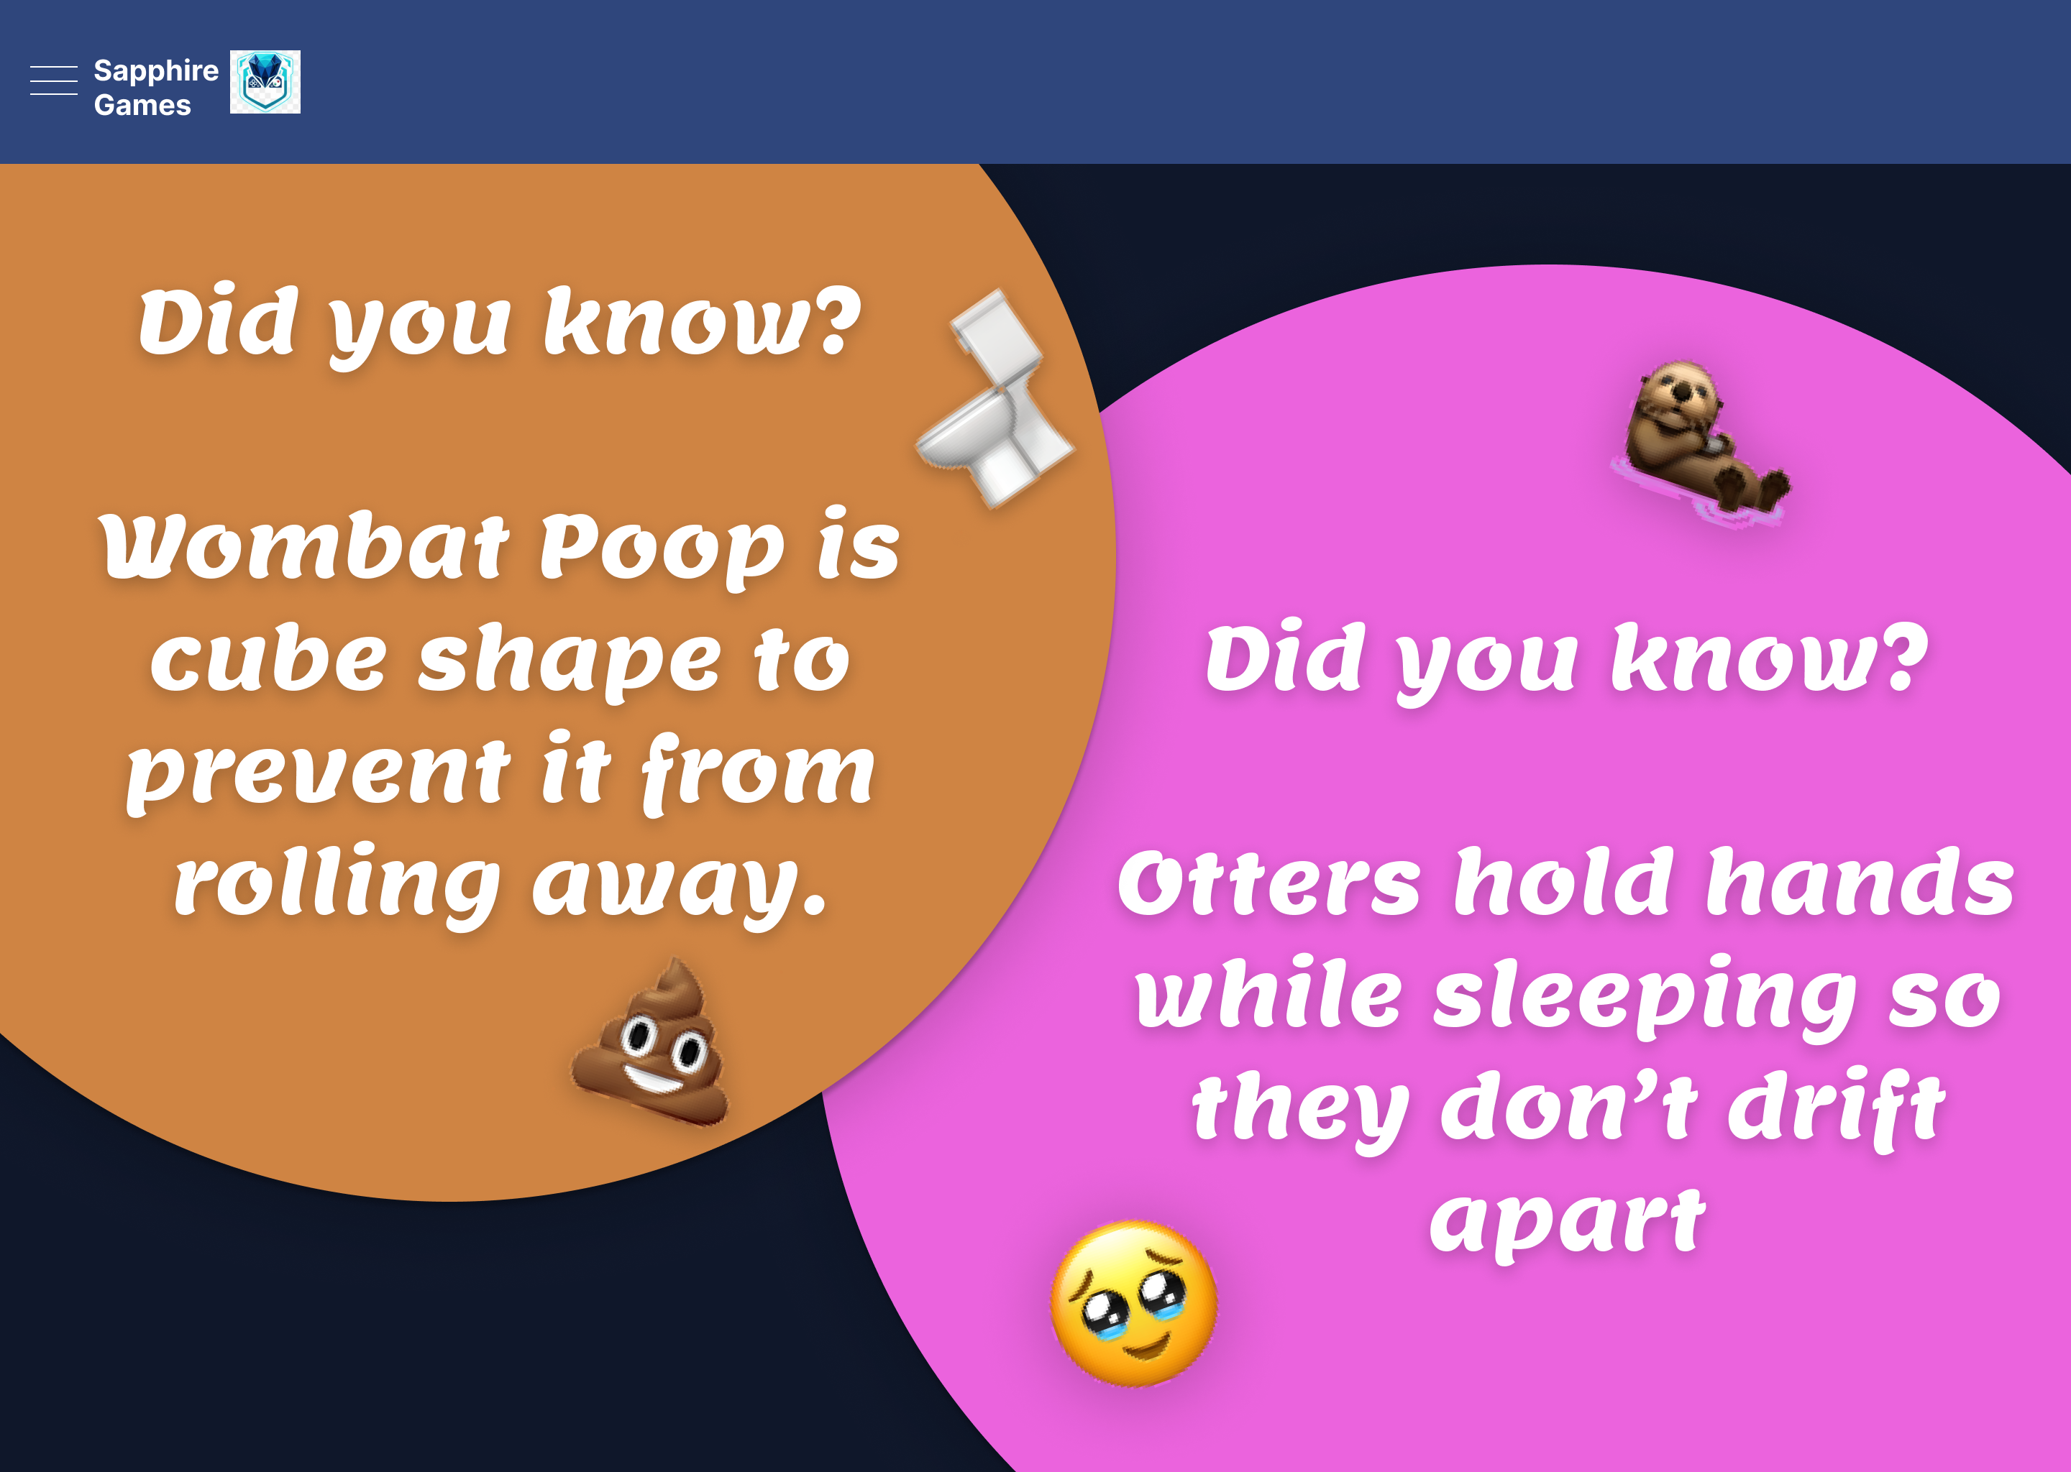
Figure V-5 Fun Facts Page
The fun fact page was inspired by Neal. Fun websites, where their astronomy and deep-sea fun facts are well known due to their visual presentations.

Project Plan
The project plan includes identifying task’s part by part, time scheduling, and progress tracking through Gantt chart for the implementation of Sapphire Fun.

Timetable
Web Technologies Project
Part 1: Report
ID | Task | Start Date | End Date | Duration | Predecessors | Notes
1 | Prepare Time Schedule and Project Plans | 9/2/2026 | 10/2/2026 | 1 day
2 | Prepare Gantt Chart and Timetable | 10/2/2026 | 11/2/2026 | 1 day | 1
3 | Background research |  |  | 2 days | 2
3.1 | Research reference website | 11/2/2026 | 12/2/2026 | 1 day
3.2 | Research APIs, Libraries, and Frameworks | 12/2/2026 | 13/2/2026 | 1 day | 3.1
4 | Prepare wireframe and page designs | 13/2/2026 | 14/2/2026 | 1 day | 3
5 | Extra resource preparation | 15/2/2026 | 17/2/2026 | 2 days | 4 | Ensure all resources are available to start writing report
6 | Make page design layout with HTML + CSS | 18/2/2026 | 25/2/2026 | 7 days | 5
7 | Write Report |  |  | 5 days | 6
7.1 | Background research & Features | 26/2/2026 | 27/2/2026 | 1 day
7.2 | Wireframes, page previews, Gantt charts | 28/2/2026 | 4/3/2026 | 4 days | 7.1
8 | Prepare presentation video | 4/3/2026 | 4/3/2026 | - | 7.2
9 | Double check resources | 4/3/2026 | 5/3/2026 | 1 day | 8
Part 1: Report Milestone
10 | Write Program for Reaction speed test & Tic Tac Toe | 7/3/2026 | 10/3/2026 | 3 days | 9
11 | Write Program for Whack a mole | 11/3/2026 | 13/3/2026 | 2 days | 10
12 | Write Program for sudoku and wordle | 14/3/2026 | 16/3/2026 | 2 days | 11
13 | Implement the programs in website design layout | 17/3/2026 | 18/3/2026 | 1 day | 12
14 | Final Inspection | 18/3/2026 | 19/3/2026 | 1 day | 13
15 | Time to think and add additional features | 19/3/2026 | 30/3/2026 | 11 days | 14 | In this stage, all implementations are expected to be complete and is for adding additional features if possible
Part 2: Implementation Milestone
Table VI-1 Timetable for Sapphire Fun

Click Up List
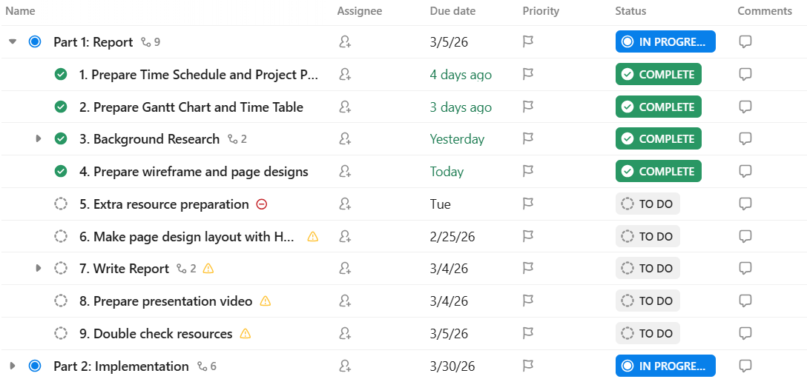
Figure VI-1 Part 1 Task List
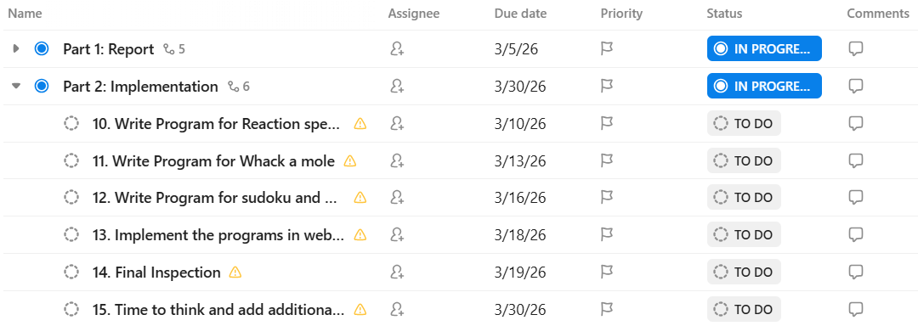
Figure VI-2 Part 2 Task List

Gantt Chart
With Gantt Chart, the development of Sapphire Fun can be kept on track without chaos.
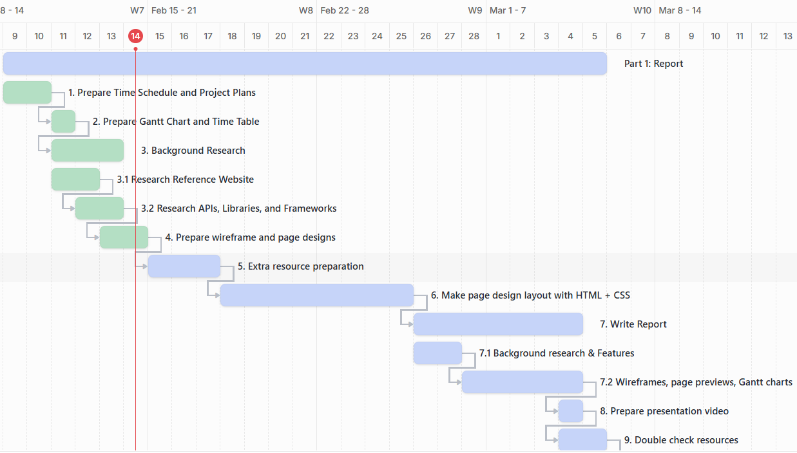
Figure VI-3 Gantt Chart Part 1 Report
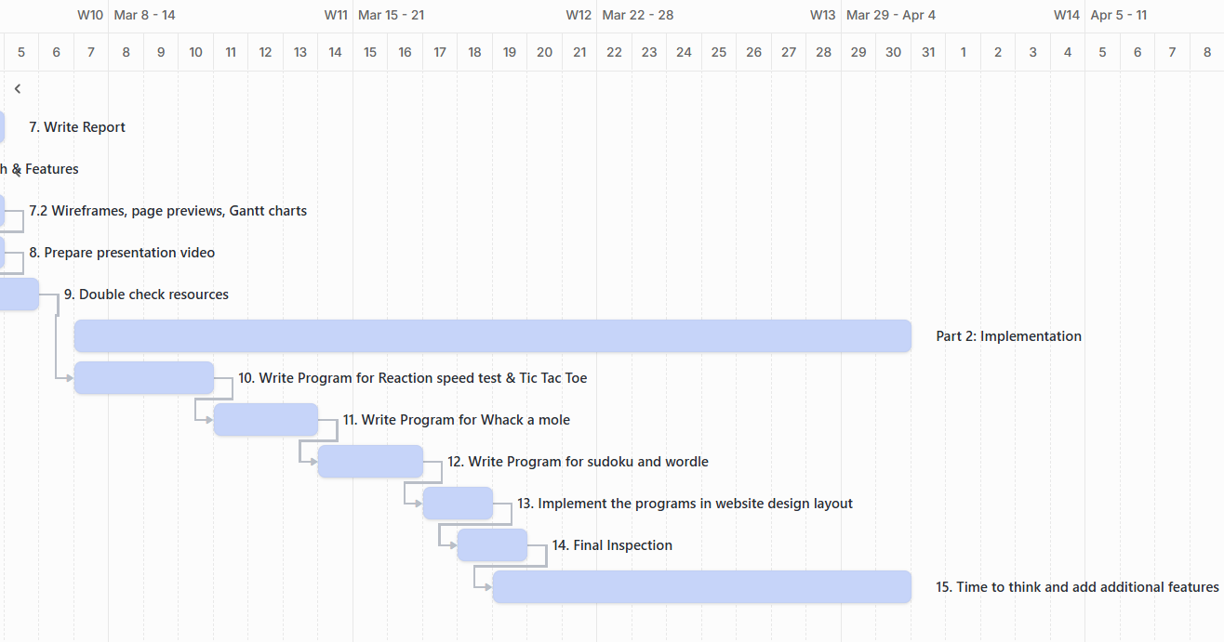
Figure VI-4 Gantt Chart Part 2 Implementation

TO DO List Table
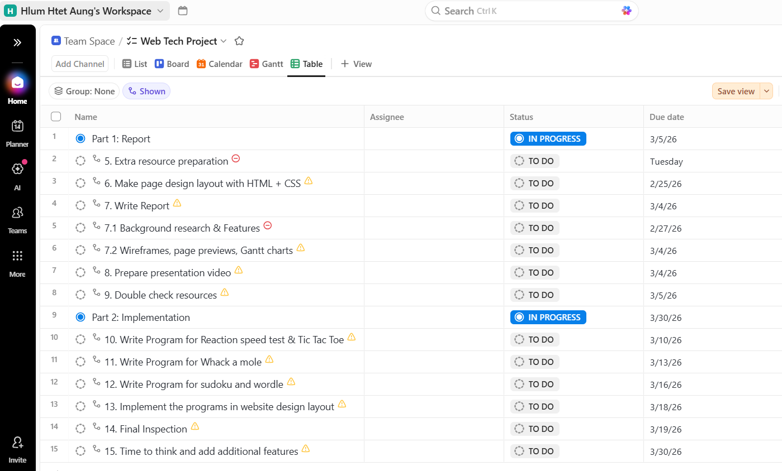
Figure VI-5 TO DO List Table for future tasks

References
CrazyGames, n.d. Crazy Games. [Online]
Available at: https://www.crazygames.com/
[Accessed 30 1 2026].
Neal, n.d. Neal.Fun. [Online]
Available at: https://neal.fun/
[Accessed 31 1 2026].
Development workspace GitHub - https://github.com/hlumhtetaung/Web_Technologies_Project
Note: In the workspace, you can see the development process, commits, pushes, and the reference YouTube videos where I will learn how to write code for games I mentioned.

